General
Thank you for buying the MFB SYNTH LITE II. It is an analogue synthesizer module that can be controlled by MIDI data. The SYNTH LITE II is monophonic and, therefore, can play one note at a time. The unit’s sound engine is equipped with 83 memory locations allowing you, the user, to access lots of different sounds, just by calling them up.

Setup
Plug the included power supply to the POWER jack at the rear of the LITE II. AUDIO OUT connects to a mixing console or directly to your sound system’s amplifier.
To play the SYNTH LITE II connect the MIDI OUT of your keyboard or computer sequencer to the MIDI IN jack of the module. External audio can be processed by connecting any appropriate line level signal to the AUDIO IN jack. It is then passed to the SYNTH LITE II’s VCF and VCA. Finally switch on the LITE II by pressing ON/OFF.

Function
The SYNTH LITE II includes all classic elements of analogue subtractive synthesis: oscillators, voltage controlled filter and amp, envelopes and a low frequency oscillator for modulations. Find detailed information below...

Oscillators
The LITE II has two main oscillators OSC 1 und OSC 2 that each offer selectable saw tooth and square waveforms. In addition OSC 1 offers ring modulation (OSC 1*2) or even triple ring modulation (OSC 1*2*3) if all LEDs are lit. OSC 2 also offers an impulse waveform shape.
The octave of each oscillator can be set to 16`, 8` or 4`. Furthermore OSC 2 can be detuned by INTERVAL at a plus-minus one octave range. With this control you access 32’ and 2’ octaves, coarse intervals and light detuning. INTERVAL only refers to OSC 2. The overall tuning of the synthesizer is set by TUNE.
An additional 32’ square sub oscillator is available, too. Press RECORD and then control the pitch interval with OCTAVE OSC2 (pitch down) and WAVEFORM OSC2 (pitch up). The level is controlled in the same way with OCTAVE OSC1 (level down) and WAVEFORM OSC1 (level up).
Important: Make sure to press RECORD again after editing to avoid overwriting user memories or sequences accidentally.

VCF
Each oscillator’s output is set with its LEVEL control. These signals plus any signal connected to the AUDIO IN are mixed and routed into the voltage controlled low pass filter. CUTOFF sets the filter working point. Any frequency higher than the cutoff frequency will be attenuated. And since the VCF operates with 24 dB/oct the attenuation is quite steep and effective. EMPHASIS enhances the CUTOFF frequency area by boosting it. When turning up EMPHASIS fully clockwise the filter even starts to self-oscillate with a sinoid wave. It might be useful to couple the cutoff frequency to incoming keyboard notes. This can be done in the System Settings by setting Keyboard Follow to ON.
External signals connected to AUDIO IN are routed directly to the VCF.
CONTUR adjusts the cutoff modulation by envelope ADSR 1.

VCA
The final stage in signal processing is the voltage controlled amplifier. Its shape is controlled by envelope ADSR 2.

ADSR
The SYNTH LITE II has two envelope generators: ADSR1 (VCF) and ADSR2 (VCA). They each offer four parameters. ATTACK (time from zero level to maximum level when triggering a note), DECAY (time from maximum level to sustain level), SUSTAIN (level while holding a note) and RELEASE (time from sustain level to zero level after releasing a note). RELEASE has no individual control. It is either fixed in duration or equivalent to DECAY (set in System settings).

LFO
The LFO (low frequency oscillator) offers selectable triangle, saw tooth and square waveforms. RATE sets the oscillation speed between approximately 10 sec and 100 Hz. If all three LEDs are lit the LFO is set to saw tooth one-shot mode. Here, the modulation is not cyclic but runs through the waveform only once when triggered.
DEPTH sets the modulation target and intensity. Turn counter clockwise from centre to modulate the oscillator section in pitch (or pulse width) with increasing intensity. Turn clockwise from the centre position to modulate the filter’s cutoff frequency. Leave the control in centre position disables LFO modulations.

Oscillator sync
Oscillator sync is activated if all OSC 2’s LEDs are lit. Every new wave cycle of OSC 1 forces OSC 2 to restart its cycle, too. OSC 2 is therefore controlled or synchronized to OSC 1 frequency. With Sync activated, modulation will only target OSC 2, resulting in intense timbres instead of pitch modulations.

PWM
Activate pulse width modulation by setting OSC 2’s waveform to impulse. A modulation will no longer target this oscillator’s pitch but its symmetry for timbral changes.

Glide
Press GLIDE to activate the Portamento/Glide function, a step less pitch transition between two adjacent played notes. The control sets the speed in which the pitch moves from the old to the new note position.

User memory
The LITE II has 83+83 User sound memory locations. To call up the memories press and hold USER followed by a combination of the six buttons to the left of the module. Pressing just one of these buttons will call up memory locations 01-06. Press two adjacent knobs. (11....16, 21....26,... 61...66) to access the memories up to 41.
An additional 42 memory locations can be accessed by pressing GLIDE button upfront the described procedure. The display will always inform you about the selected location.
Finally you can adress another 83 memory locations by switching the LITE II off and on while pressing WAVEFORM in the LFO section. The display indicates the memory bank with a dot.

Important: Location 01 is no memory location. It calls up the sound by the current setting of all knobs and controls (manual mode).

To save a sound into a memory location press RECORD. Then press and hold USER and chose the memory location just as described above. Copying sounds is done in the same way.

Setting the MIDI channel
To set the MIDI channel, press RECORD. Then press WAVEFORM (LFO) to increase the channel number up to 16 and then starting back from 1 again. Confirm channel selection with RECORD.

Pitch Wheel
Incoming pitch wheel data will result in global pitch modulation of plus minus two semitones.

Modulation Wheel
The Mod Wheel can either control the VCF (cutoff) or the VCOs (pitch), depending on the system settings.

Sequencer
The LITE II’s sequencer is accessed by pressing GLIDE, hold and selecting one of four sequences with the four top buttons. Further sequences can be selected by pressing 2 knobs instead of one. A total of 20 sequences can be recalled in this way (1...4, 11...14, ... 41...44). The sequence tempo is controlled by RATE.
All sequences can be transposed by incoming MIDI notes. To stop or change to another sequence press GLIDE again. If you hit WAVEFORM (LFO) no new sequence will be started but a NOTE ON is transmitted.
To record a sequence, press RECORD. Then select the sequence by press and hold GLIDE with the sequence number. Enter the notes from a MIDI keyboard. Note duration is ignored and automatically set to sixteenth. You can enter up to 32 notes. Simply press RECORD after the last note (no matter if you entered less than 32 notes) to define the end of the sequence. The sequence is looped continuously in playback mode.
A pause can be set at any position by pressing USER once. 1/8 notes are programmed by holding the note until the counter increases to the next step (approx. 1 sec). By holding the key even longer even quarter and longer notes can be defined.

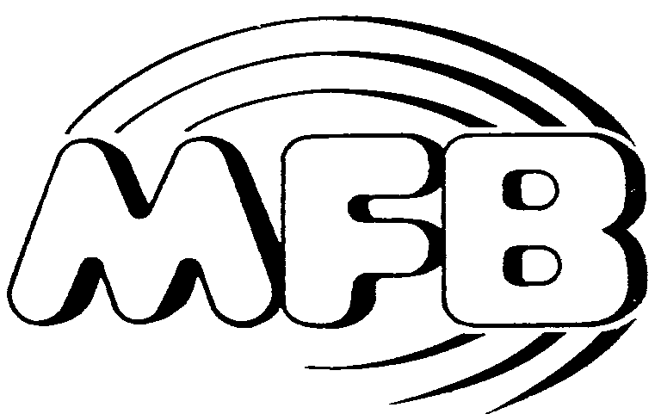

Operator’s Manual

MFB-SYNTH LITE II

