Introduction
Congratulations! The MFB-SYNTH II is a monophonic programmable MIDI-controlled analogue synthesizer module with an integrated 32 step sequencer.

Setup
Plug the power supply into the connector of your MFB-SYNTH II. The Audio Out has to be connected to a mixing console or amplifier. Connect your keyboard´s MIDI output to MIDI In of the MFB-SYNTH II then. Finally switch on the SYNTH II. The display should read 01 with the User button illuminated.

Function
The MFB-SYNTH II contains all classical elements of analogue synthesis.
The sound source are three voltage controlled oscillators VCO1, VCO2 and VCO3. Each VCO has its own waveform selector (Wave) that can toggle between sawtooth, square and triangle. VCO3 allows control of the square wave symmetry (pulsewidth). Turn left from center position to set the pulsewidth, turn right from center to activate a pulsewidth automodulation (by an LFO, see Setting system parameters).
Press Shift and Wave to set VCO1 to Oscillator Sync Mode (VCO1 will synchronize VCO2´s waveform start). Pressing Shift and Wave in the VCO2 and VCO3 section will activate ring modulations (VCO1 * VCO2 and or VCO2 * VCO3) that can be used to produce addtional harmonics.
The base pitch is controlled by the oscillators Octave switch. Select between 16’, 8’ and 4’ (32’, 16’ and 8’ for VCO3). Both VCO2 and VCO3 can be detuned by plus minus 1 octave with the Interval knobs, expanding the range to 64’-2’.
Tune controls the overall tuning of the MFB-SYNTH II.
The levels of all three oscillators, the additonal noise generator and the signal connected to the Audio Input are adjusted in the mixer. From here the signal enters the voltage controlled 24 dB/octave lowpass filter (VCF). Cutoff sets the frequency where the filter starts working. Emphasis enhances this working point for clear audibilty (Resonance). Here, very high settings cause the filter to self-oscillate.
Contour sets the amount of envelope ADSR1 on the cutoff frequency while Key does the same incoming pitch information (MIDI notes or CV).
The last stage in the signal flow is the voltage controlled amplifier (VCA). It controls the level of the synthesized signal. It is dynamically shaped by the second envelope generator ADSR2. Finally Master sets the overall level for the output.
Both envelopes ADSR1 and ADSR2 offer four parameters: Attack (time from zero level to maximum VCA level, initiated by pressing of a key), Decay (time from maximum VCA level to Sustain level), Sustain (level while holding down a key, after passing the decay time). Release sets the time to fade out from sustain level to zero level after releasing a key.
The MFB-SYNTH II has two LFOs (Low frequency oscillators) to modulate various parameters. They can be controlled in speed (Rate).
Wave selects the available waveforms. LFO1 offers triangle, sawtooth, square; LFO2 triangle, sawtooth and random wave. Pressing Shift and Wave activate the LFO´s One shot mode. Here the waveform is played only once when hitting a key. This is useful for using the LFOs as additional basic envelope shapers.
MOD.VCO controls the intensity of pitch modulation by one of the LFOs (see Setting system parameters). Turn left from center to achieve an increasing modulation for all three VCOs. Turn MOD.VCO right from center to modulate the pitch of VCO1 and VCO2 by the outout of VCO3 (FM).
MOD.VCF sets the modulation intensity for the filter cutoff. Again it´s a bipolar control. Turning the knob left from its center position activates LFO modulation of the filter while right turns will use an oscillator signal to modulate the filter with much high rates (Filter FM).
Finally MOD.VCA sets the amount of VCA level modulation either by LFO1 or LFO2.

Preset and User memory locations
The MFB-SYNTH II holds 50 (factory restorable) preset and 49 User memory locations. To recall a preset press and hold Preset and C1/1...C3/25 for the first 25 numbers. Add Shift for the upper 25 presets (26-50). To recall a user memory press and hold User and C#1/2...C3/25 for location 1-24. Add Shift to access locations 25-49. The display will show the corresponding location. User location C1/1 is no memory. It is used to switch to the actual knob switch setting of the synth (Manual mode).
Remember: After having recalled a memory location the actual knobs and switches may not correspond to the stored parameters. They have to be moved or switched for edits. Only Master Volume and Tune are not stored and therefore always in the right position.

To store a setting hit Shift and Record (the display will show 2 dots), then press either User or Preset followed by the memory location you want to use (C1/2...C3/25). Use Shift to access the upper 25 locations. On successful storage the synth will exit record mode.

To recall the factory presets press Shift and Preset while switching the machine on. All your presets will be gone and be automatically replaced by the factory setting

Sequencer
The step sequencer can be programmed by the 25 integrated keys (C1/1...C3/25). Use Shift for two additional octaves. To select a sequence press and hold Sequence and C1/1...C3/25. The display will show the selected sequence location.
To record the sequence press Shift and Record (the display will 2 dots). Hit the keys to set pitches. Breaks are set pressing Play. Legato Notes can be set by holding the key and hitting the Pause button; e.g. C2+Pause, C2= 1/8 Note or C2+Pause, C2+Pause, C2+Pause, C2= 1/4 Note.
Each sequence can hold up to 32 steps. The last step is confirmed by pressing Record.
Play will start playback of the sequence in loop mode. The speed is set by the Data knob. (Hit Tempo first). It is displayed in BpM (one dot will indicate Tempi above 100, two dots above 200).
In playback mode the sequence can be transposed by Shift and C1/1...C3/25 or an external keyboard. It is even possible to recall another sequence while playback (Press and hold Sequence plus C1/1...C3/25). The new sequence will start when the actual sequence reaches its last step.

It is even possible to change the steps 1-16 of the active sequence while it´s playing. Select the step on the keyboard by pressing C1/1....D#2/16 and change the pitch with the data encoder. To store the edited sequence press Shift and Record.

Glide
To achieve a continuous pitch transition between two played keys use the Glide function. The knob sets the speed of the transition.

Setting the MIDI Channel
Press Shift and then Tempo to set the MIDI Channel with the DATA encoder.

Audio In
External audio sources can be connected to the Audio Input jack. It is directly routed to the filter (VCF). In ordner to let the incoming signal pass through one has to trigger the VCA envelope. Use the Audio In to control the level.
In case no external audio source is connected to the Audio In the output of the VCA is fed back to the filter. Increasing levels will result in a controllable Feedback loop.

CV In
The CV In connector is a stereo jack. It can be used to control the pitch of the MFB-SYNTH II. The control voltage must arrive at the tip, the Gate information on ring 1. The gate information has to be positive with at least 5V. The 1V/Oct CV spreading can be fine tuned (see Setting system parameters).

Other functions
The MFB-SYNTH II is equipped with MIDI. It can be played dynamically using keyboard velocity information. Activate Dynamic VCF and/or Dynamic VCA to control filter cutoff and level (see Setting system parameters).
The synthesizer corresponds to MIDI clock, Start and Stop informations when it is set to external clock (SYNC, see Setting system parameters). When set to internal the MIDI clock, Start and Stop information are sent to the MIDI output.
Incoming MIDI information of Pitchbend and Mod-Wheel are reflected. The system setup (see Setting system parameters) sets the amount of pitch bend and the destination of the Mod-Wheel. The speed of the modulation is controlled by the Rate knob.

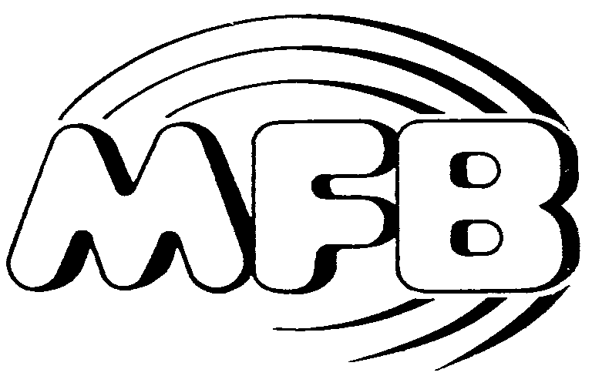

Owners manual

MFB-SYNTH II

