General
The OSC-02 module combines three oscillators, ring-modulation, hard-sync with individual modulation- and control-inputs. The analog circuit is based on the oscillator-design found in MFB-SYNTH II and MFB-Kraftzwerg.

Hint: Since the oscillators in OSC-02 are an analog design, it is recommended to leave the unit switched on five to ten minutes before performance or recording.

Set-up
OSC-02 is fully compatible to Doepfer’s A-100 modular system - in size, bus-power and CV/Gate voltage. Connect the 16-pin cable to a corresponded 16-pin jack on the Doepfer mainframe bus. Supply voltage needs to be +/- 12 volts, 5-volt connections are not required. The wattage is +/- 40 mA, the module size 16 TE (Teileinheiten).

ATTENTION: Please, check for correct polarity! The colored side of the connector-cable needs to point downwards so that the cable is not twisted.

Functions
OSC-02 makes use of the Doepfer A-100 mainframe/system bus for Key-CV-signals. Naturally, the bus needs to be fed by either an appropriate MIDI-CV-converter or a Bus-Access module. The signal needs to conform to the 1-volt/octave-standard and is meant to be used for oscillator pitch control by a keyboard or sequencer.
All three oscillators will receive the same control voltages (or pitches) when using the mainframe bus. To send individual control voltages to the oscillators, it is necessary to use the front panel inputs CV1-3. By using a front-panel input, the corresponding oscillator is automatically disconnected from the mainframe bus.

CV-inputs 1-3 and audio-outputs are interconnected. This means, that a CV-signal present CV1 will also control OSC2 and OSC3, when not separately patched. For example, with CV3 being patched, OSC3 is disconnected from the control signal present at CV1, while OSC1 and OSC2 are still under combined CV1 control.

The function for the audio outputs is comparable: Out3 carries the signals (sum) of all three oscillators. With Out1 or Out2 being patched, these signals will be subtracted from Out3. To avoid internal clipping, the summed output signal at Out3 is slightly reduced in level compared to the single output of OSC3.

OSC 1
OSC1 is tuned by the global Tune control.
There is a choice of three waveforms, selectable by Wave1 switch:
- Triangle
- square
- saw tooth
The square wave's symmetry (pulse width) can be controlled by CV4 (see below).
Octave1 switches between the octave registers 16‘, 8‘ and 4‘. Pitch is controlled by CV1 or the mainframe CV-signal. The required voltage needs to be within a range of 0 to 5 volts.

Additional CV-control can be provided through input CV4. By this, you can add vibrato or a pitch-envelope. Depending on the setting of the corresponding switch, the input voltage controls either pitch (OSC1) or pulse width (PW1). This input accepts voltages ranging between -5 and +5 volts. The shared control CV4+5 sets the modulation intensity.
Global pitch modulation of all three oscillators is possible, using input CV6, switched to ALL.

OSC1’s audio output is Out1 or the summed output Out3 as described above.

OSC 2
OSC2 is widely identical to OSC1. Octave and waveforms are selected just like on OSC1. In addition to the global Tune control, OSC2 offers detuning of plus minus one octave using the Interval2 knob.
Independent pitch control is achieved by using input CV2, compared to common control through the mainframe bus or input CV1 (with CV2 unpatched).

Additional voltage control for modulations like vibrato or pitch envelopes can be provided through input CV5. Depending on the setting of the corresponding switch, the input voltage controls either pitch (OSC2) or pulse width (PW2). This input accepts voltages ranging between -5 and +5 volts. The shared control CV4+5 sets the modulation intensity. OSC2 is also modulated when using CV6 switched to ALL.

OSC2’s audio output is Out2 or the summed output Out3 as described above. With Out1 not patched, Out2 carries the signals of both OSC1 and OSC2.

Hint: Modulation of OSC1 and OSC2 (CV4 and CV5 inputs) with different intensities requires attenuation of one of both control signals prior to the CV-input. You may use a VCA or a mixer to achieve this, since the module itself only allows shared intensity control through CV4+5. On the other hand, this control acts fine to fade the overall modulation in and out.

OSC 3
OSC3 is widely identical to OSC1. Octave and waveforms are selected just like on OSC1. Here, the octave selection is shifted an octave down, much like on a sub-oscillator.
However, using the Octave3 switch and Interval3 control, you can always set OSC3 to the same pitch as OSC1 and OSC2 or create any possible interval.
Independent pitch control is achieved by using input CV3, compared to common control through the mainframe bus or CV1, CV2 inputs (with CV3 unpatched).

Additional voltage control for modulations like vibrato or pitch envelopes can be provided through input CV6. Depending on the setting of the corresponding switch, the input voltage controls either individual pitch (OSC3) or common pitch (ALL). This input accepts voltages ranging between -5 and +5 volts. Control CV6 sets the modulation intensity.
OSC3’s audio output is Out3. With Out1 or Out2 not being patched, Out3 also carries the signals of these oscillators.

Ring modulator
OSC-02 also includes a digital ring modulator. Its output is available at RingOut. The sound is a result of the selected waveforms and the oscillators' pitches. Typically, the signals of OSC1 and OSC2 are used for ring modulation. However, OSC3’s output may also be included, by removing the Ring3 jumper located on the circuit board’s back (mid-left).

Hard-Sync
The OSC-02's oscillators can be synchronized internally or externally. OSC3 acts as master when internally synced. Its lower pitch is best suited for this application. Depending on the position of the Sync switch, either OSC1 or both OSC1 and OSC2 act as slaves. Inputs CV4 and CV5 allow the synchronized oscillators to be modulated by envelopes, LFOs or CV-sequencer signals.
Any external signal send to input Sync In will replace OSC3 as sync-reference. A proven choice as external sync signal is a square waveform. Other waveforms will often not deliver a sufficient sync reference.

Calibration
Oscillators OSC1 ... OSC3 each offer a control to set their tuning (Tune1 ... Tune3). A second set of controls allow calibrating the spreading (Cal1 ... Cal3).

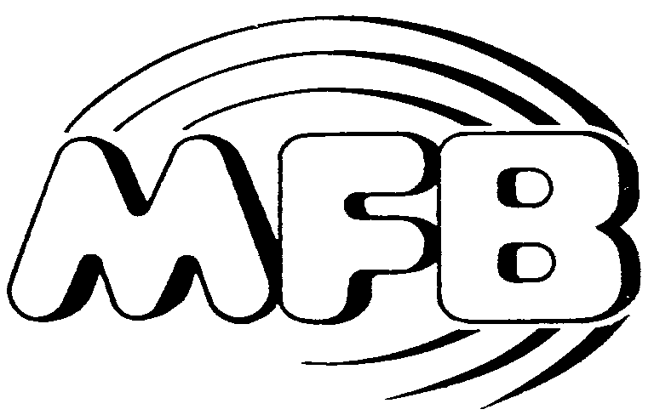

Operating Manual

OSC-02 Module

